Vasilina Orlova

Affects of (Im)Mobility in the Remembrance of the Soviet Sublime:
Staying in a Siberian Village

This presentation is a part of a bigger project—titled “Cities of the Future: Infrastructures of Nostalgia and Hope in Post-Industrial Eastern Siberia.” My work is concerned with question, what keeps people living in the places that survive infrastructural and environmental abandonment.
Siberia had a share in great Socialist transformation, and one of the “constructions of the century,” Bratsk dam, deterritorialized numerous villages. With the collapse of the USSR, these villages on the shore of the Angara River, now also known as the Bratsk reservoir, suffered reduction of government support and decline in population. In Anosovo, three out of four people either moved away or died since the 1970s. People who stayed, went from state employees to precarious subjects relying on skills of hunting and gathering. But they refuse to resettle in more comfortable places even when they have opportunities, such as connections, resources, and skills. I am using the theories of affect (Deleuze, Massumi, Stewart) and theories of infrastructure (Larkin, Simone, Gupta) to argue that rather than seeing “immobility” of “the dispossessed” (Humphrey) as dictated by socio-economic opportunities (as is pretty much a convention), we must take into consideration the “immobility outcome” as an exercise of agency and personal choice. I use ethnographic methods to show how people who stay in the communities that suffered environmental or infrastructural disaster, imagine and are committed to the rebuilding of the future. They harbor the affinity to the places of their living, which in this cases are the embodied portrayals of “the Soviet sublime,” and they have no desire to enter the regimes of the ordinary available elsewhere. They are situated within the affective infrastructures of people-made materialities that shape quotidian mobilities from movement around the kitchen to selecting a place to live.
The main place of my fieldwork is the village of Anosovo, Eastern Siberia. From 1970s to 2019, Anosovo shrunk from more than 2,000 people to 515. The place that is at the center of this presentation is the village of Karda in 60 miles from Anosovo. In its heyday in the 1970s and the 1980s, about five hundred people lived in Karda in houses with intricately adorned window frames. In 2002, 79 persons lived there, according to Goskomstat. In 2008, regional officials closed the village of Karda and transported people to the towns of Ust Uda and Usl Ilimsk. But several individuals remained.
Both villages were among the locations displaced in 1961 as the result of the construction of the Bratsk dam—the infrastructural construction that was intended to strike the awe out of viewers, the embodiment of the state power and the Soviet sublime. Despite coming into existence as a result of construction of the Bratsk dam—once the world’s most powerful provider of electricity—the village of Anosovo is still powered by diesel engines that crack under Siberian winter freezes. While the officially abandoned village of Karda, or what remains of it anyway, is powered, ironically, by solar panels.

Kardinian Dwellers

Rumors about Karda in Anosovo are abundant and contradictory. Some people say that there are pigs so fat they can barely move lying in the middle of every street, and chicken walk around unafraid of dogs and passersby because dogs are well-fed and well-trained, and passersby, nonexistent. Some say, there are only two individuals living in Karda. Still others insist that Kardinian population consists of ten and even more people. Ever since Karda was closed, most communication with Karda ceased. Few Anosovians have ever been to Karda: “What is to do there?” [“A kovo tam delat’?”].
In 2016, I glided down the Angara River on a riverboat to Anosovo and passed the village of Karda. I knew that the village was no longer in existence, but I saw a person approaching the riverboat on a boat. The water sparked dropping from a pair of oars.
The village of Karda used to sit high on the hill. One could not see Karda hid in a little gulf from the riverboat. The riverboat used to go in the gulf and stop for several minutes. Now it passes Karda pausing for a moment, sometimes, when Kardinians approach the riverboat. That was precisely the scene that I observed. In the boat, there was a young man. One of the riverboat passengers jumped into the boat, someone threw him his bag, and the boat departed to Karda.
Before I saw young men in a boat from Karda, I was under a melancholic misconception that the Karda returnees must be elderly people reluctant to embrace a more urban way of living. When Valentin Rasputin portrayed the emotional devastation wrecked on people of Matyora induced by the flood of the Bratsk dam, he devoted poignant pages to the anticipatory nostalgia of older generations.
As I observed young men stirring back to Karda, I asked a crewman of the riverboat whether they lived there alone. “A woman kashevarit for them,” He responded.
“But there is no road. What if something happens?” I asked.
“There is a winter road, zimnik,” He said measuring me with his eyes. “But no one maintains it, so, yes, you could say, there is no road. If something happens, then it happens.”
I was still looking at the boat quickly turning into a spot against the bright surface of the river as the riverboat picked up speed.
I got to Karda in 2018. When most people living there were gone, two brothers, Dmitry and Edward Ogurtsovy, stayed. Dmitry went to the town of Ust Uda, looked at the decaying house that the government offered as a replacement for his house, and turned back. Edward was in the army when the relocation took place. When he returned, the village was gone. He remained. Soon Dmitry brought his wife, Karolina, from Atalanka. Another man from Atalanka, Anton, decided to join Kardinian dwellers.
They formed one small community of Kardinians. When Parfyonov, who they often recalled in their conversations, was alive, he lived on his own, separately. The vagabond, Maxim Belodedov, once approached this shore and settled here. Once Parfyonov helped him when Belodedov was sick, and possibly saved his life. Belodedov lived nearby, in a couple of kilometers, alone.
Another family in Karda living separately consisted of a father and a son between his twenties and thirties. Dmitry, Karolina, Edward, and Anton expressed their unanimous misunderstanding as to what the father was thinking allowing his young son to live here without any prospect of ever getting married as there were no eligible bachelorettes in the vicinity. As they shrugged their shoulders, I watched them in fascinated disbelief because Anton and Edward, of 39 and 36 years, respectively, appeared to be bachelors in the same position themselves.
As Dmitry, Karolina, and I embarked on our roaming of the remainders of Karda on a hill, Dmitry joked, almost not intoning, that we will walk through the village and reach the cemetery, and they will leave me there. As we were browsing empty village, Dmitry commented with a motionless face, “This is the house where an old woman killed an old man.”
I did not know whether he was joking about the murder, and Karolina couldn’t confirm or disprove because she grew up in Atalanka. The house he pointed out still stood. He was either a jester or the sole bearer of this memory, and there was no way to know.

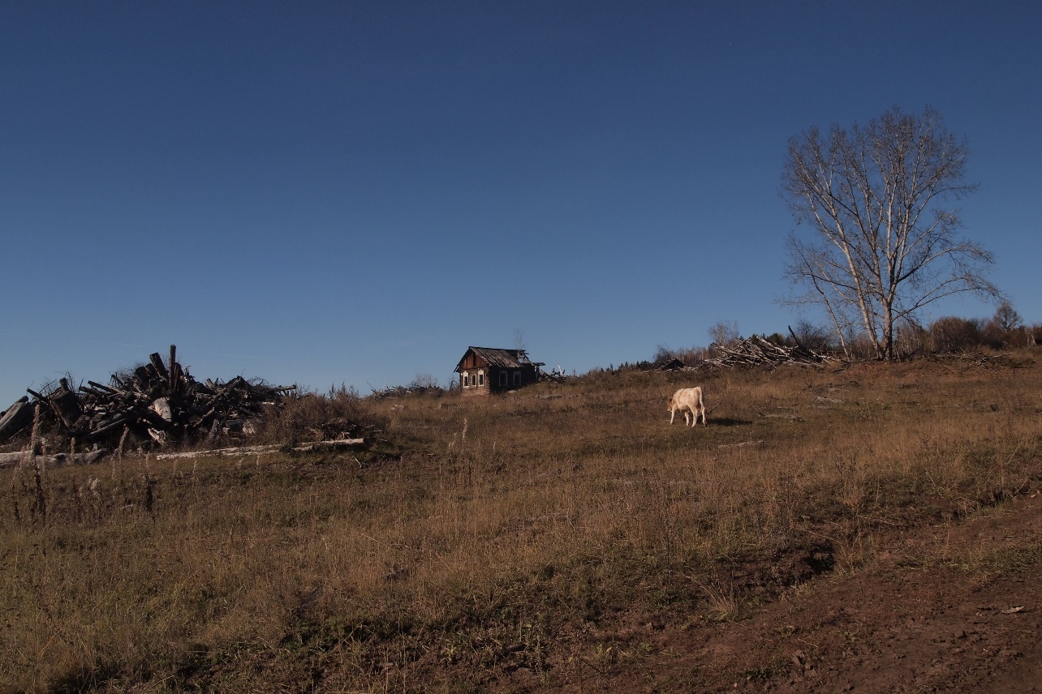
The officially abandoned village of Karda is in reality not abandoned. Karoline’s white cow pastures in front of the apocalyptic landscape.

“Ruini” (ruins), said Karolina, and this may be the first and only time that I heard this word in my Siberian travels uttered by someone other than myself. Coming from someone else, the word revealed its maddening imprecision: these were not ruini—ruins are something marble and ancient—these were razvalini, which is the Russian word situated between “rubble” and “ruins.” “Razvalini” means the material remnants of a construction but without “ruins”’ somewhat-elevated quality.
A singular pile of bricks that survived better than wood emerged in the depopulated Karda as a memorial to the Soviet times. It was the remnant of the club. From the wooden building itself, nothing remained, but the technician’s booth stood.
Dmitry recalled that in the 1980s, he watched films in this club: Indian melodramas, late Soviet films, and Western action movies. He did not remember a lot as he was a kid but named The Terminator and Back to the Future. I watched the same set of movies in the club of a Ukrainian village where I spent my summers. “Did you watch Flight of the Navigator?” I asked, but he did not recall. Still, we had a world in common.

Conclusion
There are at least three Kardas nesting within one another: the drowned Karda, the disbanded Karda, and the contemporary Karda—all take on a slightly different geographic location but share the toponym. The layering of Karda is illustrative of the layering of the historic periods as they sedimented in landscape.
Thus, the three Kardas existing together, some on the border of visibility or beyond, nonetheless share one quality: indeed, they all were frontiers, but they were the frontiers of different countries, if not civilizations. While the first Karda belonged to the tsarist imperial Russia and the second was the fruit of the industrialization of the Soviet state, the third Karda is a product of the Russian Federation in its current state. Karda is one of many post-Soviet heterotopias, of sorts.
So what keeps people living there? We grow into our places like plants grow into earth. This is partially encapsulated by the term “rooted,” “rootedness” in mobility studies. People also don’t sit in one place but conduct quotidian mobilities, peregrinations, returning to their “moorings.” They not as much do not move as they return anchored in space that they know to be their home. They are attached to the surrounding materialities of affective infrastructures. The body exists in space the way it cannot be taken out of space and relocated seamlessly. The relocation is going to be a rapture. But this is not merely to avoid raptures that people choose to remain or return and “stay put,” as Kate Brown (2009) puts it (no pun intended). There is a “positive” content to this choice because Kardinians perceive Karda as a “peaceful” place, they are outside of control of the state and surveillance, they have freedom to do as they please, and seem to be content with their little community to the extent that they do not even talk to forest rangers when those appear, and they imagine a future that the urban milieux do not answer to.

References

“А ково там делать”? Dialecticism. It is vaguely evocative of lists “Things to do in such and such a city” that American cities put on their websites to attract tourists.
Parthé, Kathleen. "Village Voice: Peasant Nostalgia in Recent Oral History." Post-Soviet Nostalgia: Confronting the Empire’s Legacies 76 (2019).
Prepares food: “stews porridge.”
Gaston Gordillo suggesting that the ruins should be replaced with rubble blah blah; also did he really suggest it? revisit

